Match the picture of the traditional dish to the country.

1. 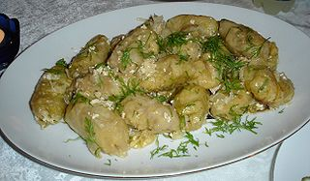 Minced meat in cabbage leaves

a. Romania

b. Poland

c. Turkey

d. Italy

Answer: a

2. 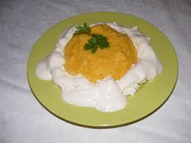 Polenta with cheese and cream

1. Turkey
2. Poland
3. Italy
4. Romania

Answer: d

3. 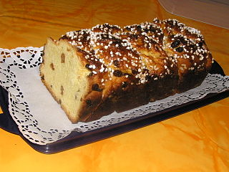 Christmas sweet bread

1. Italy
2. Turkey
3. Poland
4. Romania

Answer: d

4. 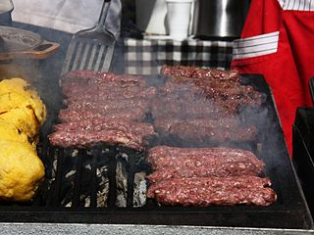 Grilled ground meat rolls/Mititei

1. Bulgaria
2. Poland
3. Turkey
4. Romania

Answer: d

5. 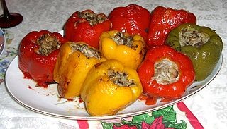 Stuffed peppers

1. Turkey
2. Romania
3. Italy
4. Poland

Answer: b